A000-AM,S-Peru-Nazca-Feline Decapitator God with Heads-Polychrome ceramic double spouted vessel-200 CE

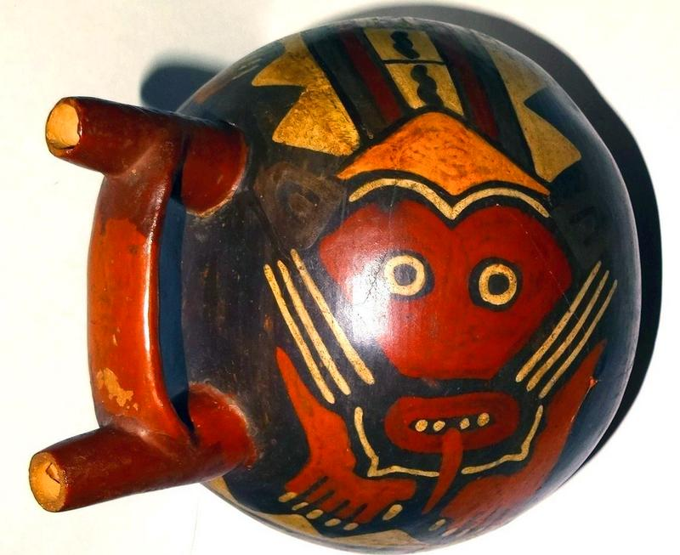 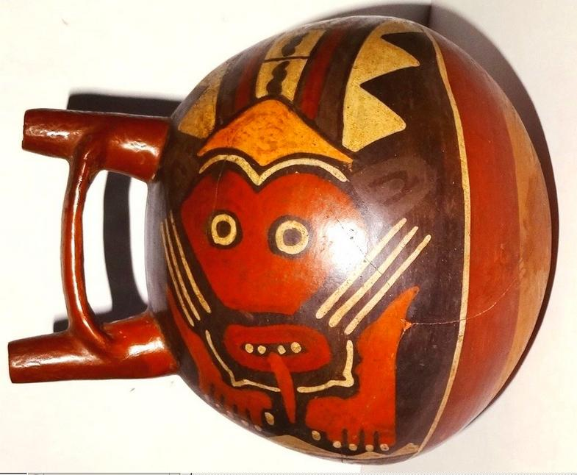

AM,S-Peru-Nazca-Feline Decapitator God with Heads-Polychrome ceramic double spouted vessel-200 CE

Case No.: 10

**Accession No.**

**Formal Label:** AM,S-Peru-Nazca-Feline Decapitator God with Heads-Polychrome ceramic double spouted vessel-200 CE

**Display Description:**

Nazca-Feline Decapitator God with Heads-Polychrome ceramic double spouted vessel-200 CE

# He holds a weapon in his hand. This vase has been glazed in red and painted with yellow, red, brown and white to create a series of patterns and pictures.

The Nazca culture is characterized by its beautiful polychrome pottery, painted with at least 8 distinct colors. The shift from post-fire resin painting to pre-fire slip painting marked the end of Paracas-style pottery and the beginning of Nazca-style pottery. The use of pre-fire slip painting meant that a great deal of experimentation took place in order to know which slips produced certain colors. Major pottery shapes include double-spout bottles, bowls, cups, vases, effigy forms, and mythical creatures. Archaeologists have excavated highly valued polychrome pottery among all classes of Nazca society, illustrating that it was not just the elite that had access to them. Commoners were able to obtain these goods through feasting and pilgrimages to Cahuachi. In addition, clays matching the chemical signature of polychrome pottery found all over the Southern Nazca Region have been found near Cahuachi. However, there is no substantial evidence of pottery production at Cahuachi. The site was most likely a redistribution center for ceramics

**LC Classification:**

**Date or Time Horizon:**

**Geographical Area:**

**Map:**

**GPS coordinates:**

**Cultural Affiliation:**

**Media:**

**Dimensions:** height 180 mm, diameter 165 mm

**Weight:**

**Condition: restored. Original.**

**Provenance:**

**Discussion:**

**References:**

